Date:
CO:

EXPERIMENT 5:
Corrosion Assessment in Rebars of RC Structures Using PZT Patches

Objectives:

This simulation experiment is based on experimental data measured during actual accelerated corrosion tests carried out on reinforced concrete (RC) structures:
- 5A) Bare Rebar
- 5B) Embedded Rebar

Theory:

The corrosion of steel reinforcement is one of the main causes of damage and premature failure of reinforced concrete structures, increasing the costs for inspection, maintenance, restoration, and replacement of infrastructure. Recently, Dr. Talakokula and Prof. Bhalla (2015) proposed a new corrosion assessment approach based on the mechanical impedance EMI technique (Refer thesis of Dr. Vislalakshi Talakokula for more information). Figures 1(a) and 1(b) present the experimental setup for the rebar corrosion related laboratory experiments for bare rebar and embedded rebar respectively.
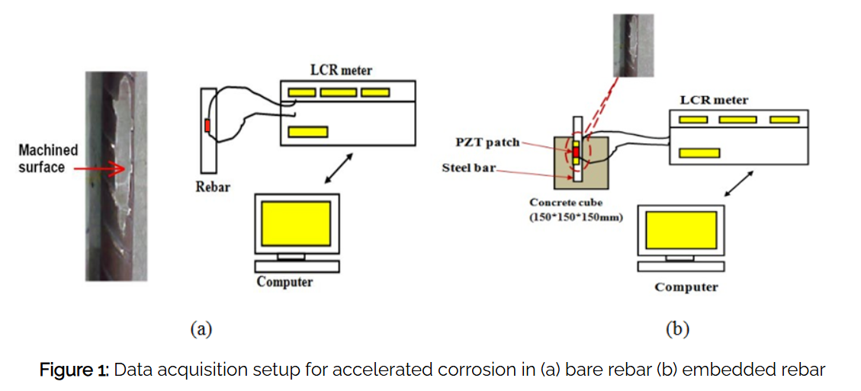

EXERIMENTAL DETAILS

In the accelerated corrosion experiments of bare rebar, following components are used:
- Copper rod acting as Cathode.
- Bare rebar acting as Anode.
- PZT patches bonded to rebar which is further connected to LCR meter by electrodes.
- Beaker containing brine solution whose salinity is 35 parts per thousand.
For accelerated corrosion experiments in embedded rebars, the components are same except that a 150 x 150 x 150 mm concrete cube with an embedded bar replaces the bare rebar as shown in Figure 2(a) and 2(b) respectively.

EXPERIMENTAL PROCEDURE
The setup for accelerated corrosion for bare rebar and reinforced concrete is shown in Figure 2(a) and 2(b) respectively. Through this animation, the user can visualize the process of accelerated corrosion and can obtain signatures of the PZT patchs bonded to rebar during various stages. Figure 2 shows a screenshot of the animation. The user can visualize the process by plotting in excel and observe the changes in signature with increasing corrosion.

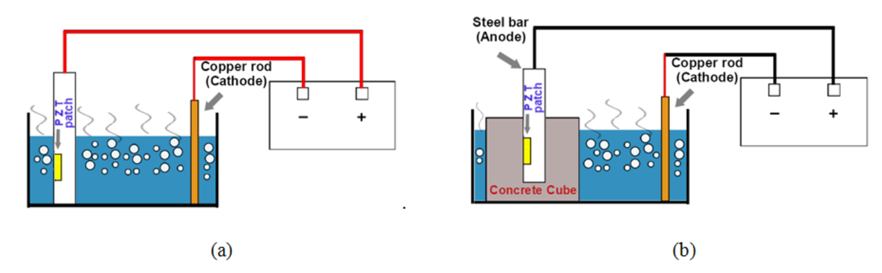

Figure 2: Setup for accelerated corrosion (a) Bare rebar (b) Reinforced Concrete

To statistically quantify damage, compute root mean square deviation (RMSD) in conductance by following equation directly in MS excel:
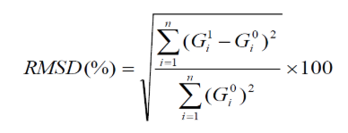
where
G_{i}⁰ = Baseline conductance value at i^{th} frequency.
G_{i}¹ = Conductance value after a damage at i^{th} frequency.
n = No. of frequency data points
As an exercise plot a histogram of RMSD for the various damaged states. Note your observations and draw conclusions.

Apparatus:
- For Bare Rebar:

- Empty Tank
- Brine solution
- Copper rod as cathode
- Bare rebar as anode
- PZT patch
- Power supply
- Bare rebar holder
- Copper rod holder

- For Embedded Rebar:

- Empty Tank
- Brine solution
- PZT patch
- Power supply

- Copper rod as cathode
- Copper rod holder
- Concrete cube containing rebar as anode

SELF EVALUATION:

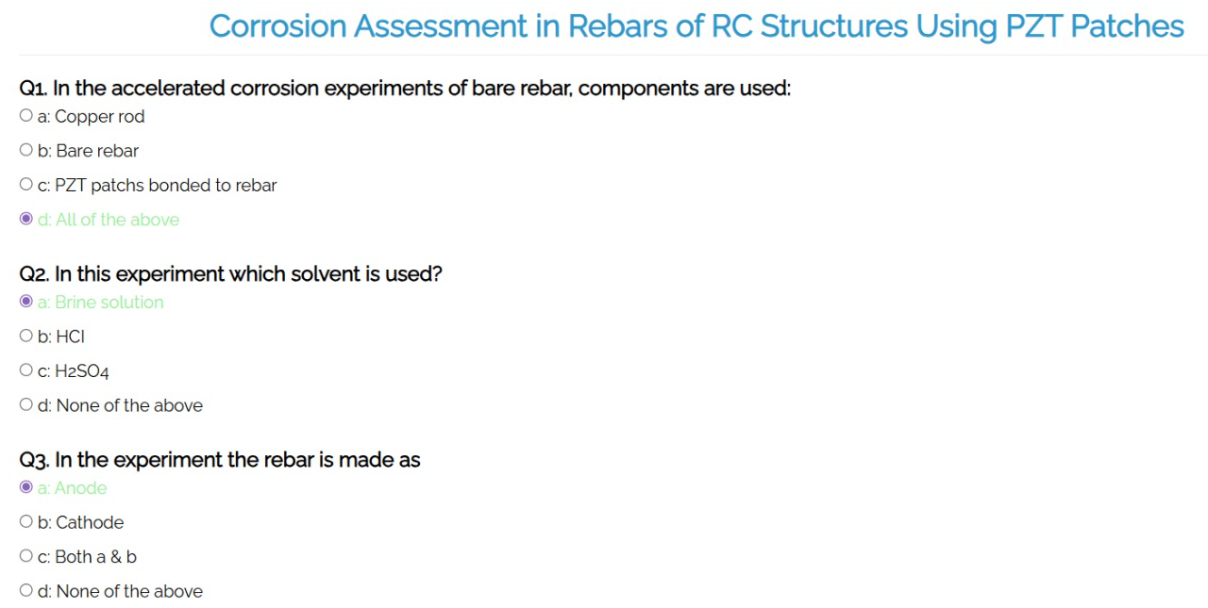

PROCEDURE:
EXPERIMENT 5 A: BARE REBAR

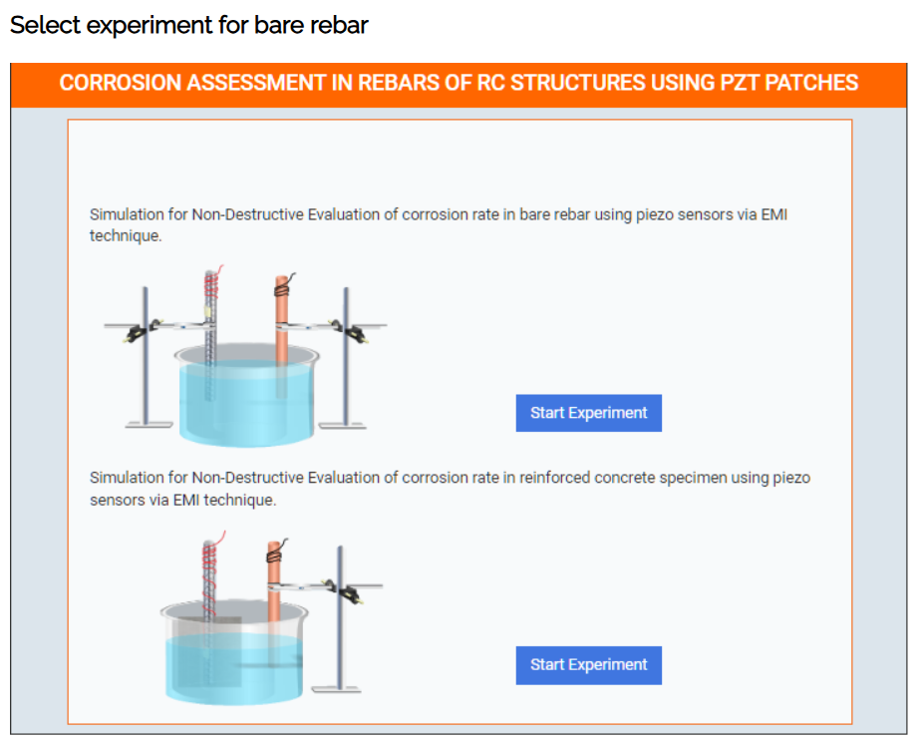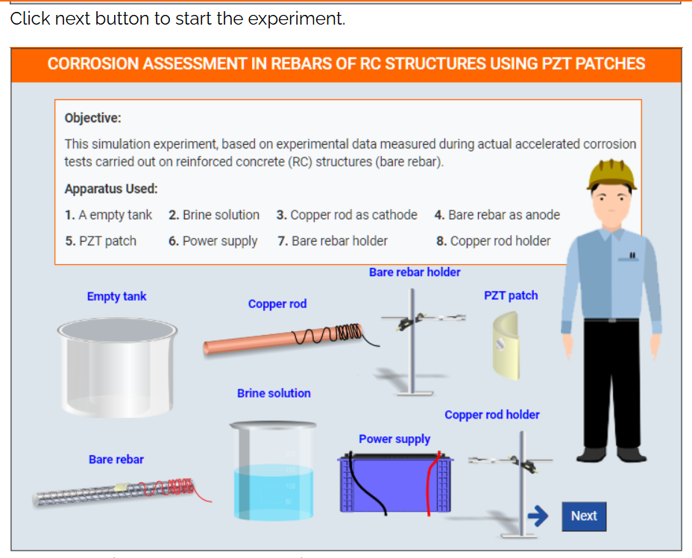

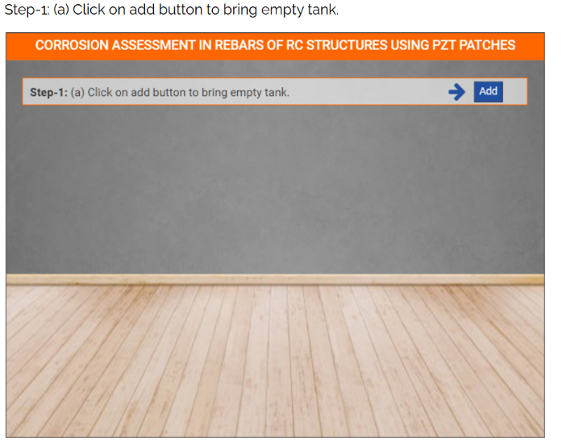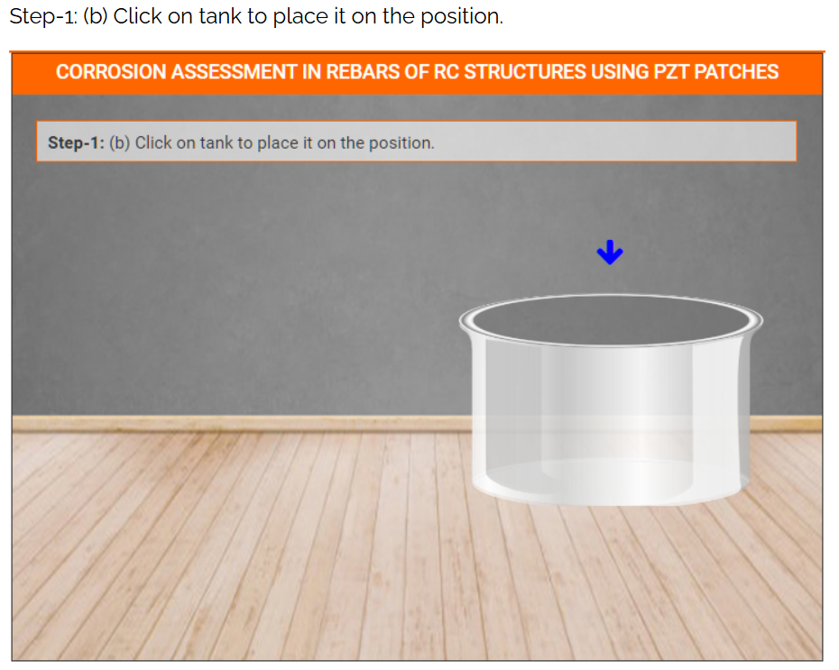

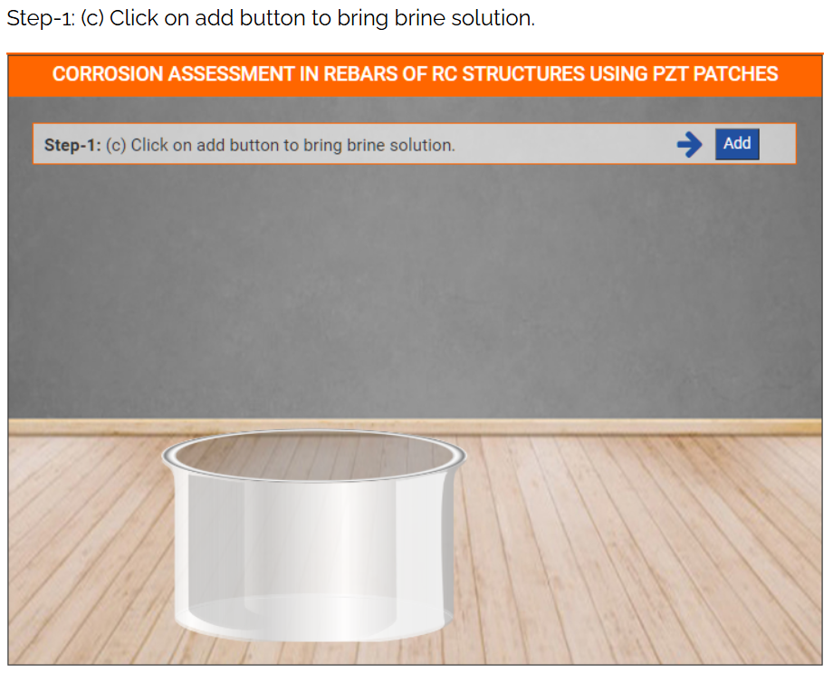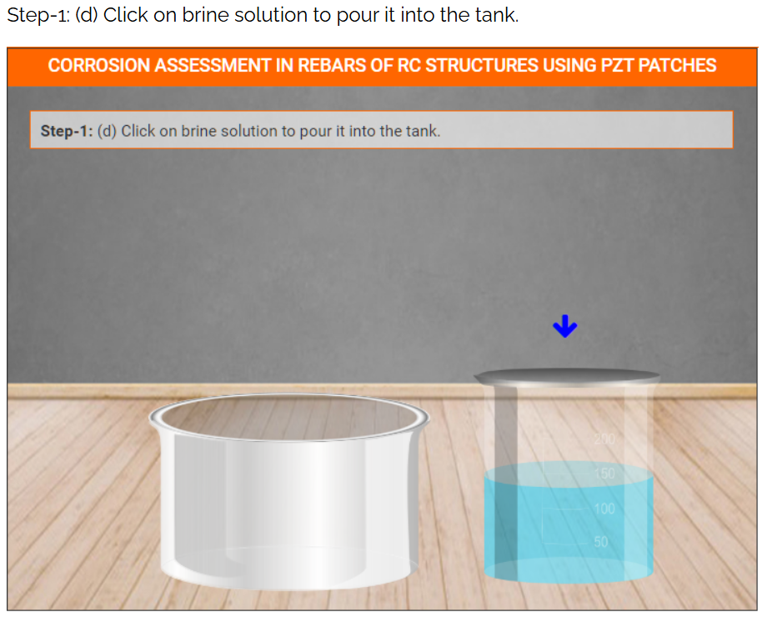

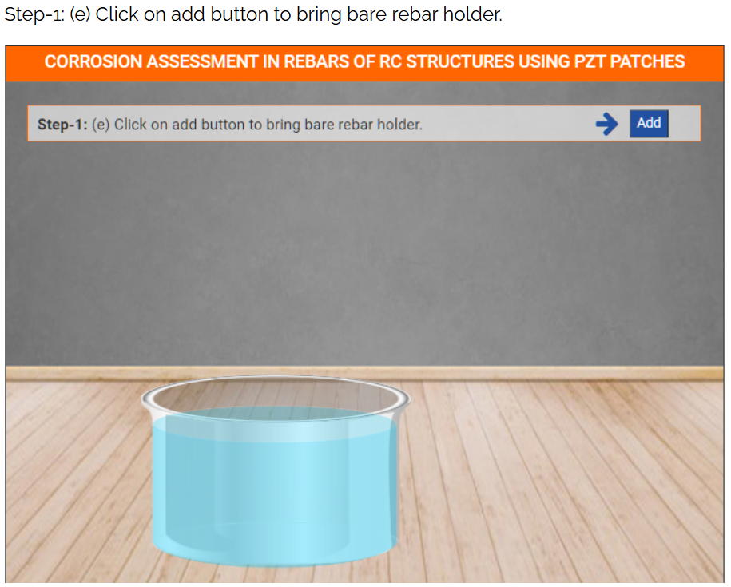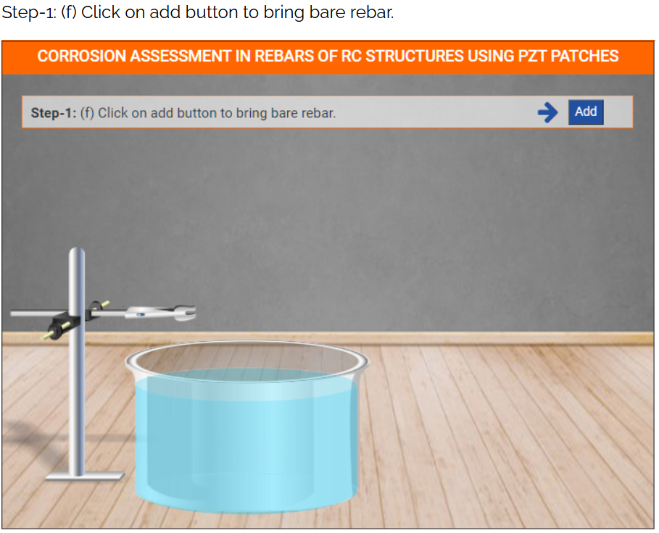

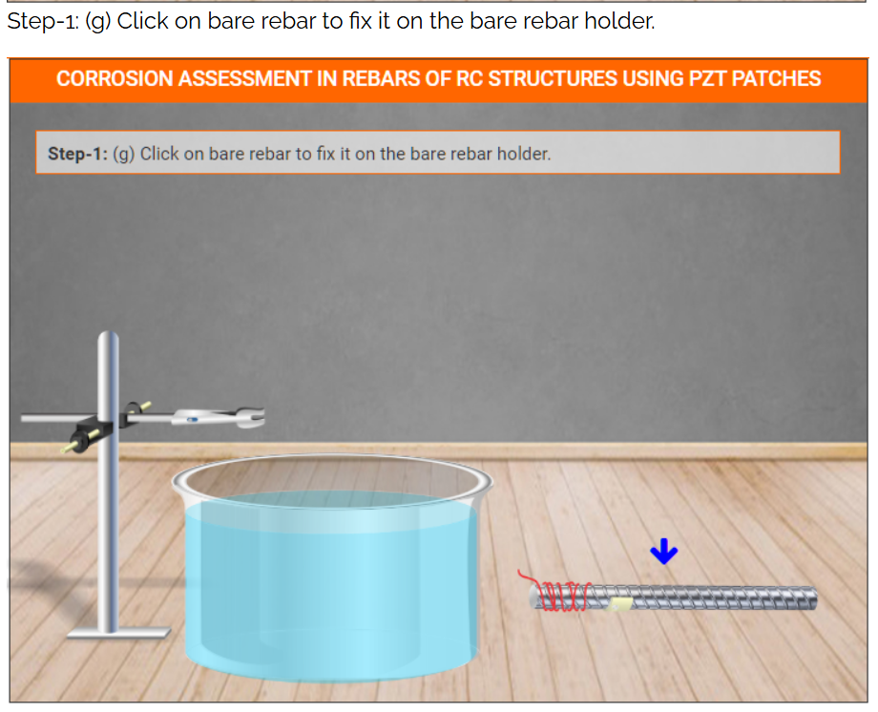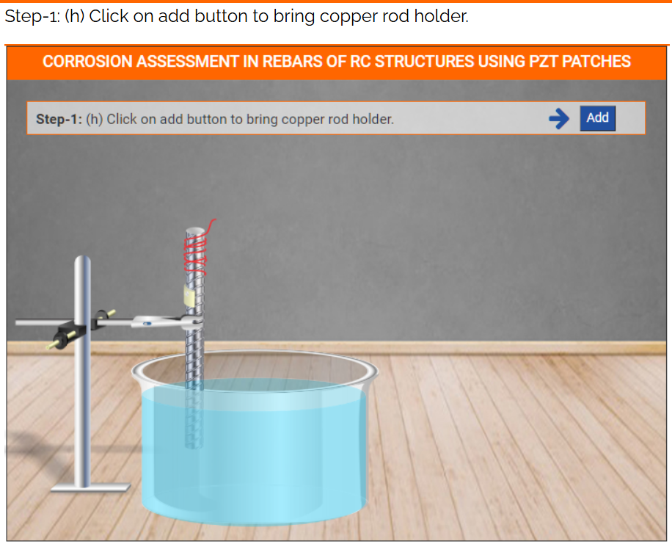

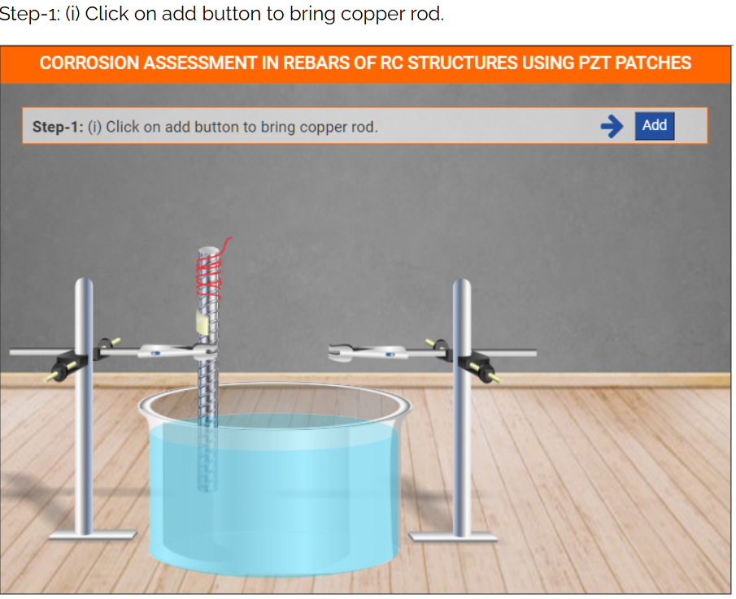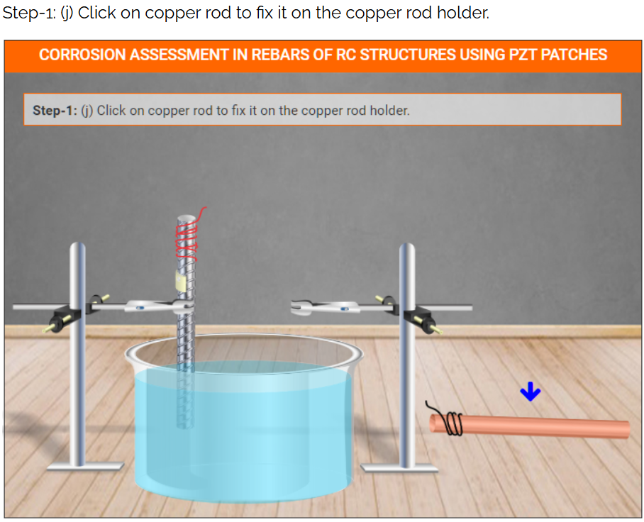

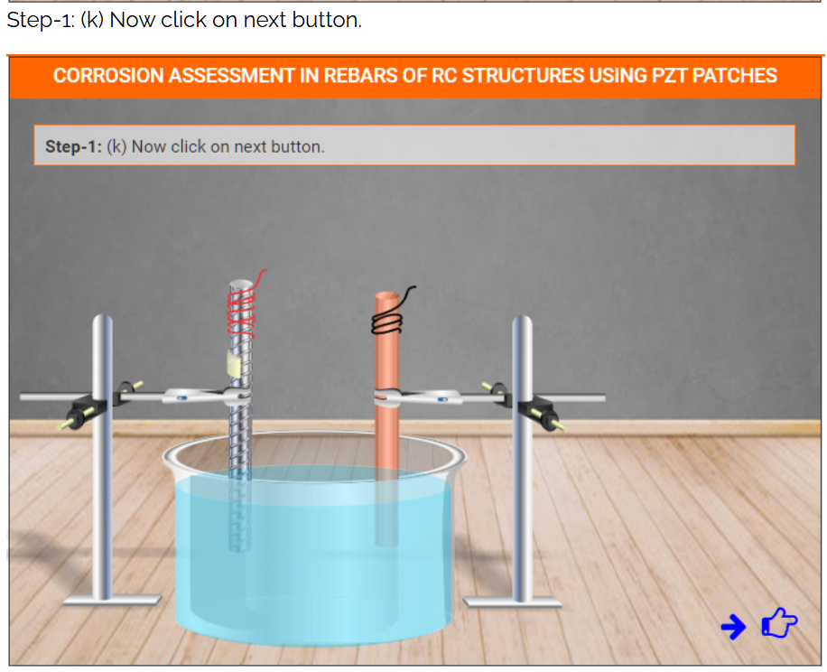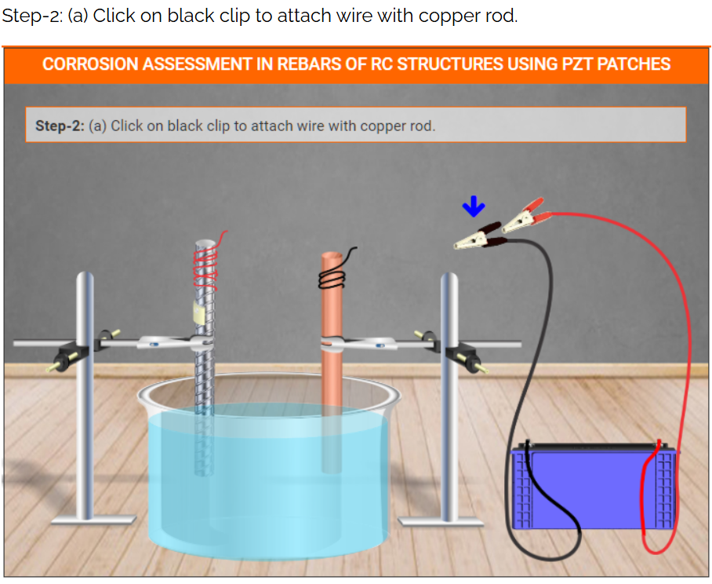
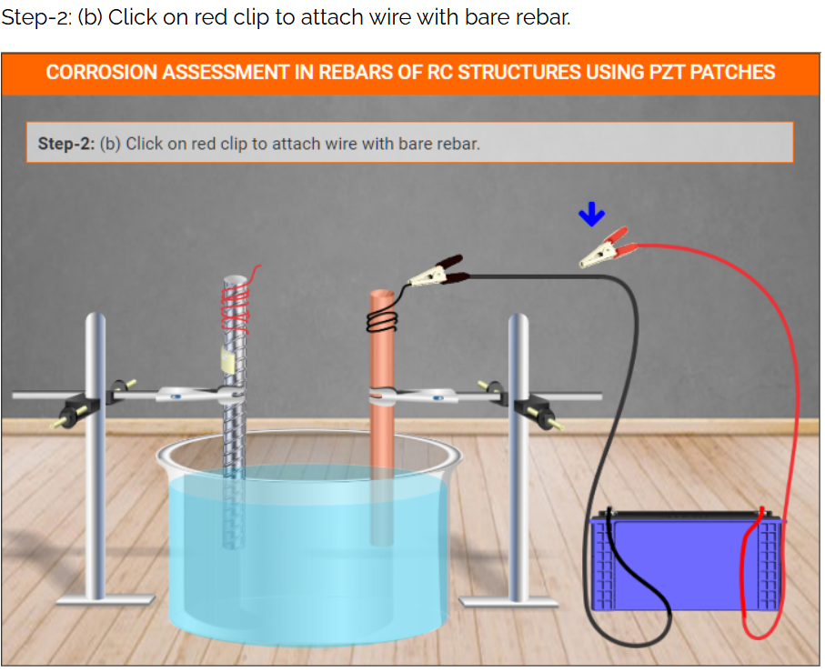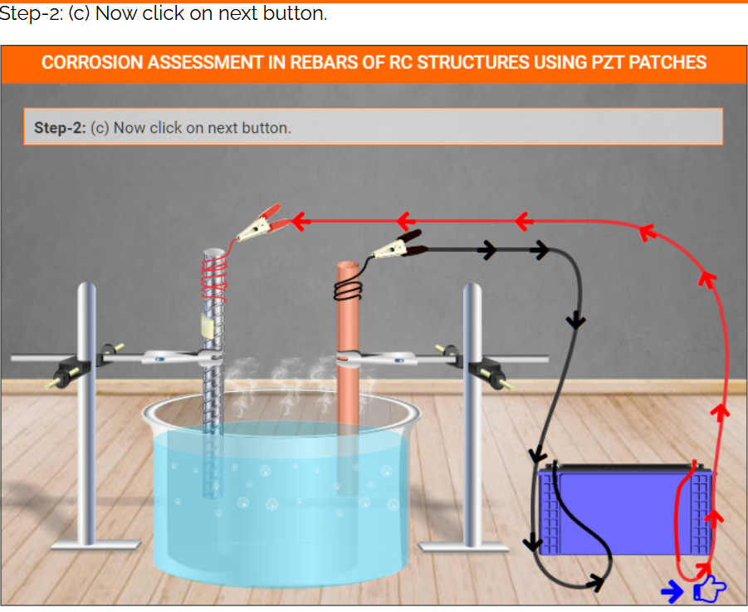
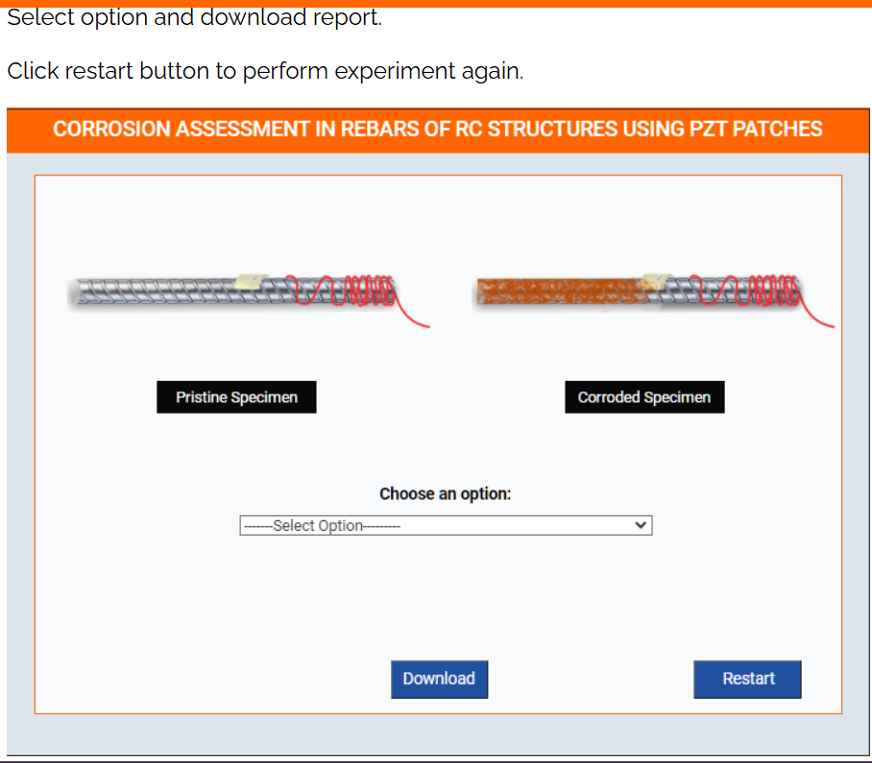
EXPERIMENT 5 B: EMBEDDED REBAR
Select experiment for embedded rebar
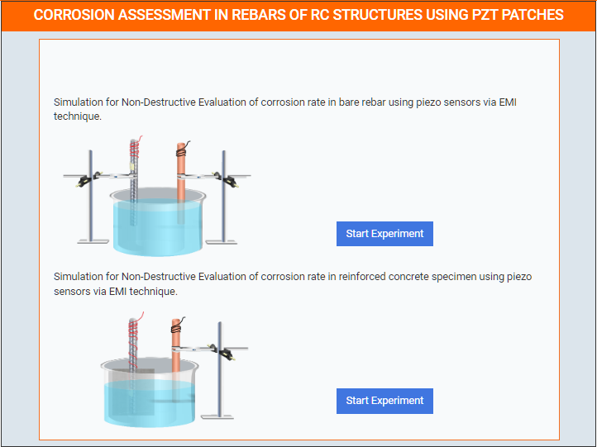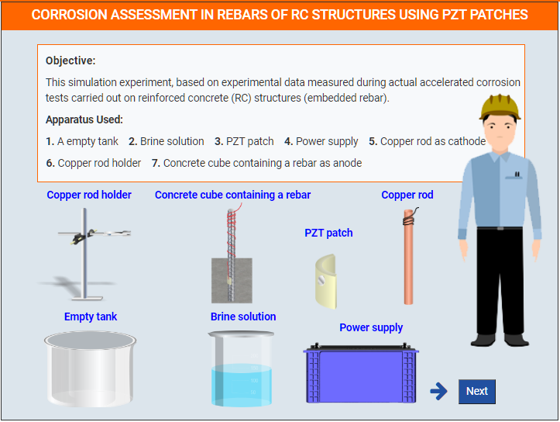

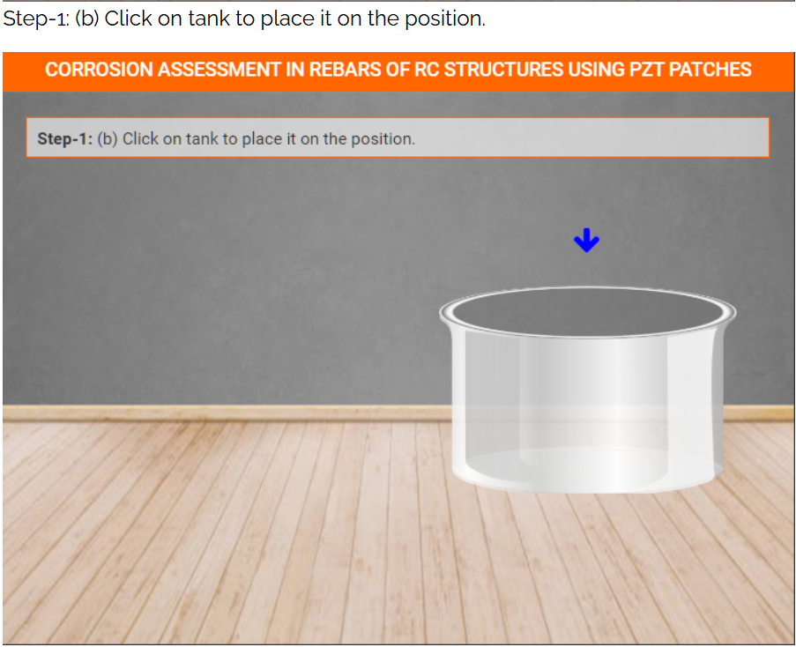

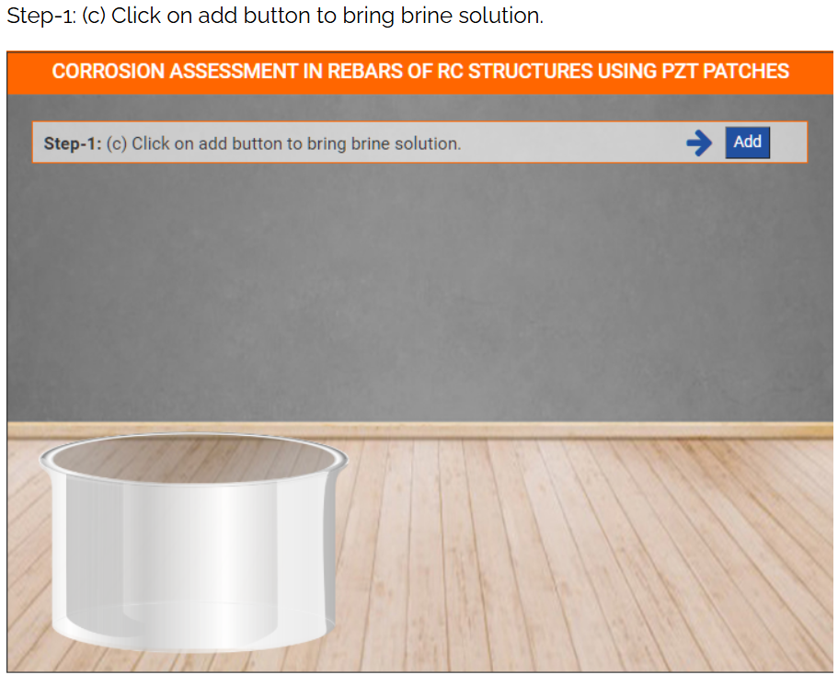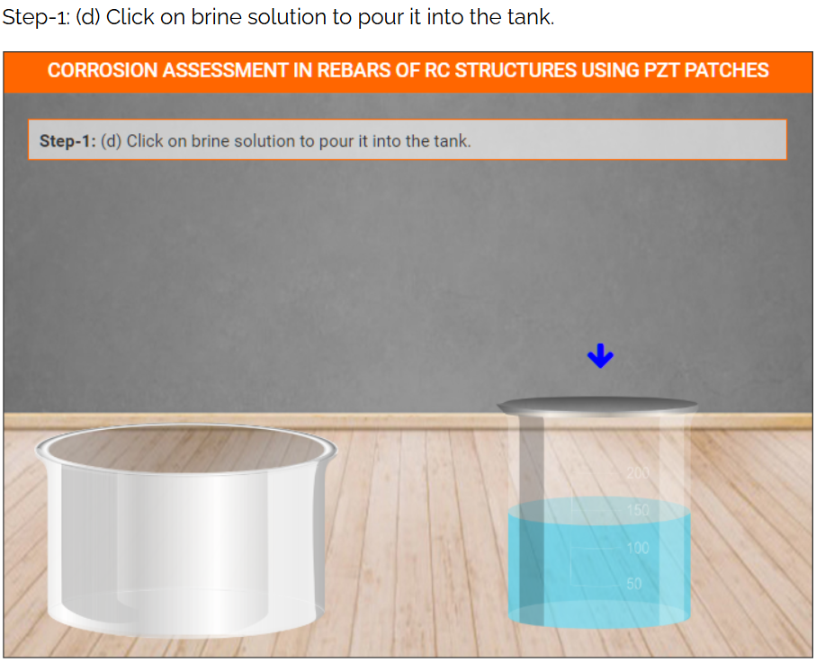

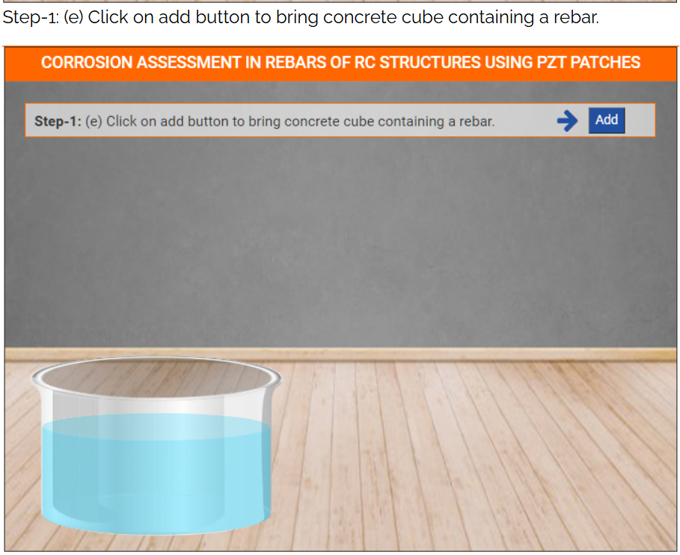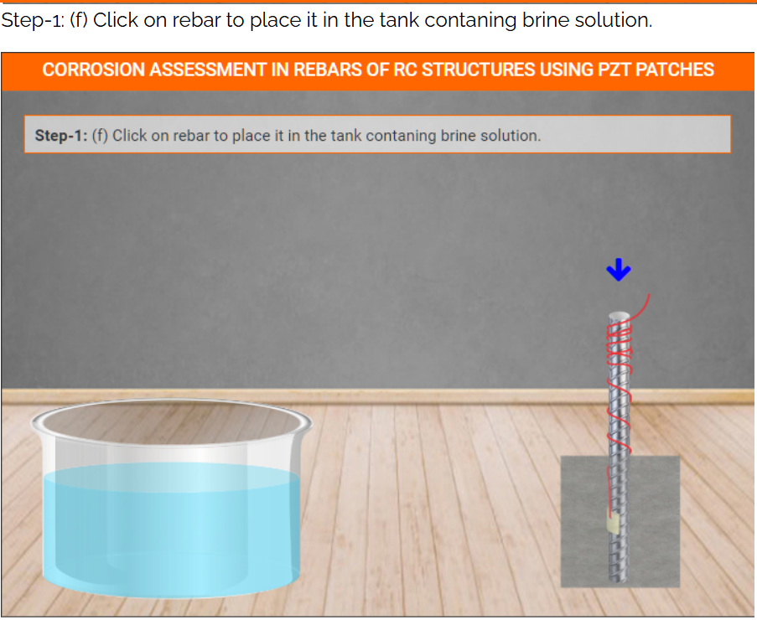

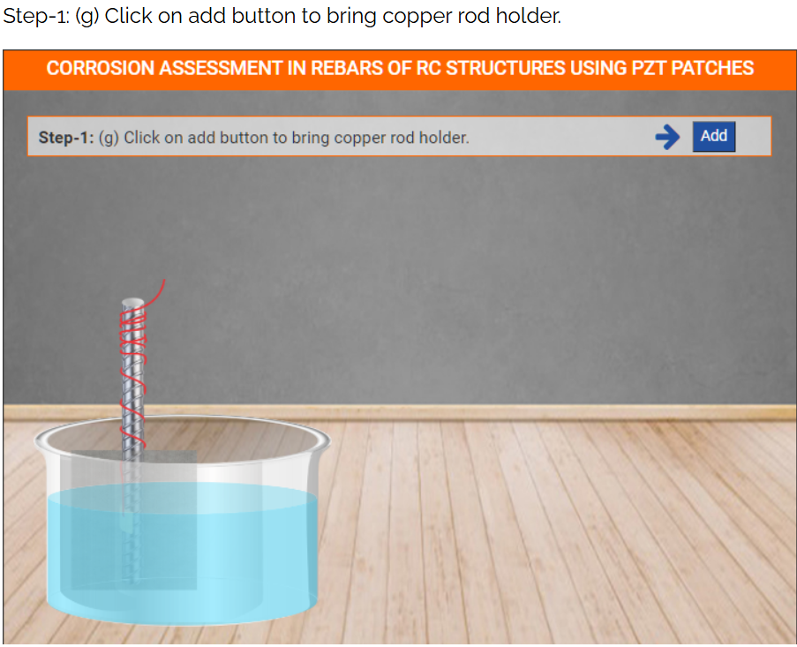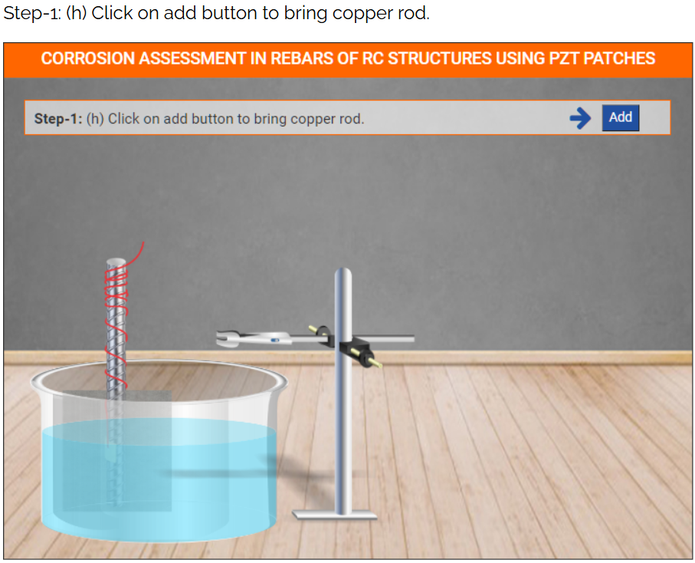

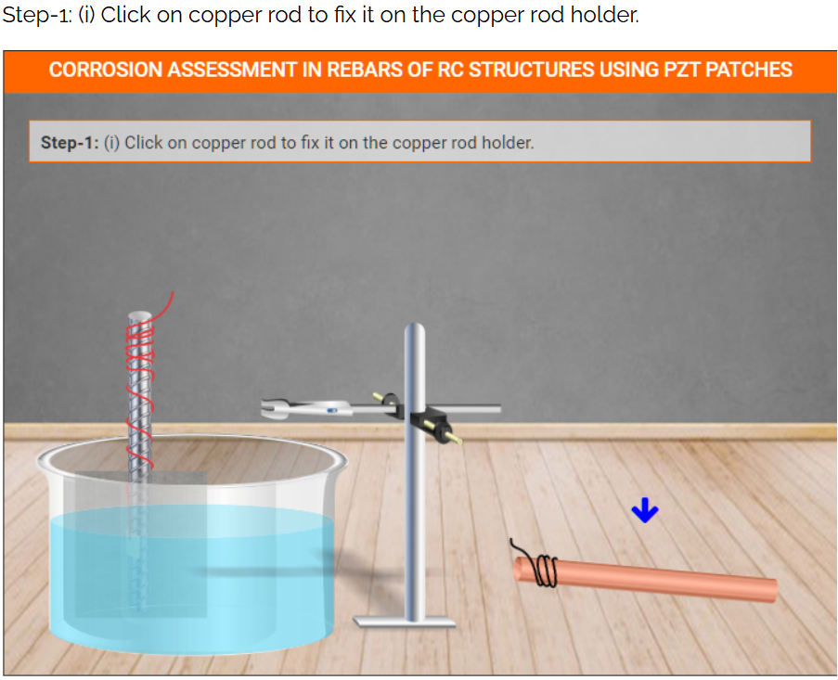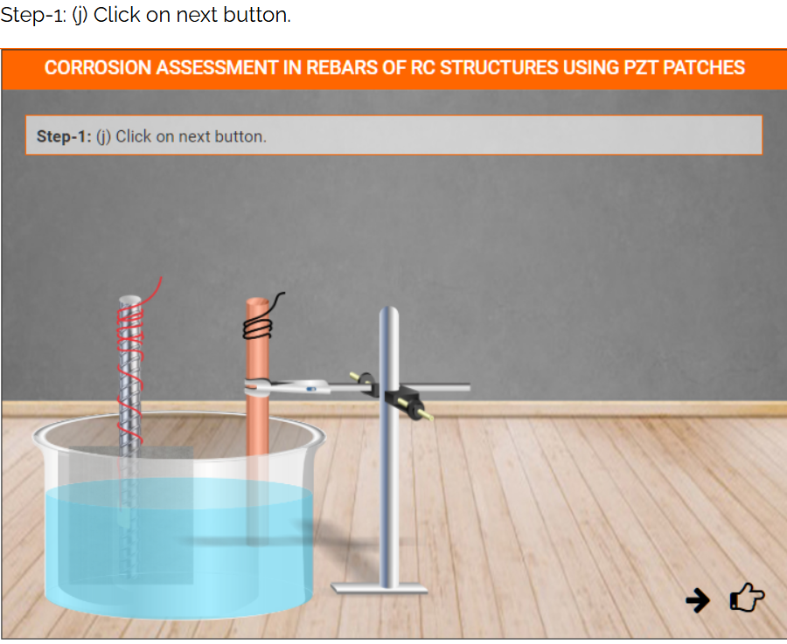

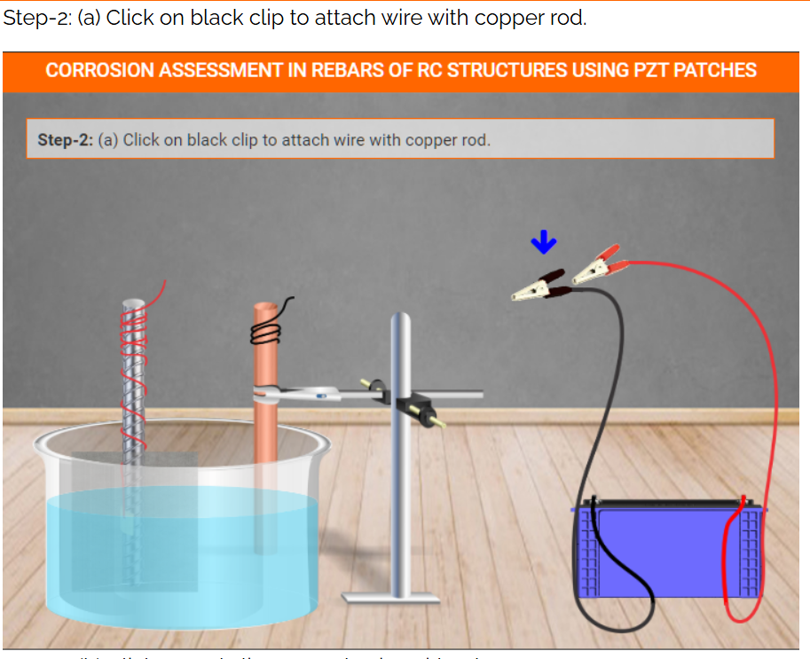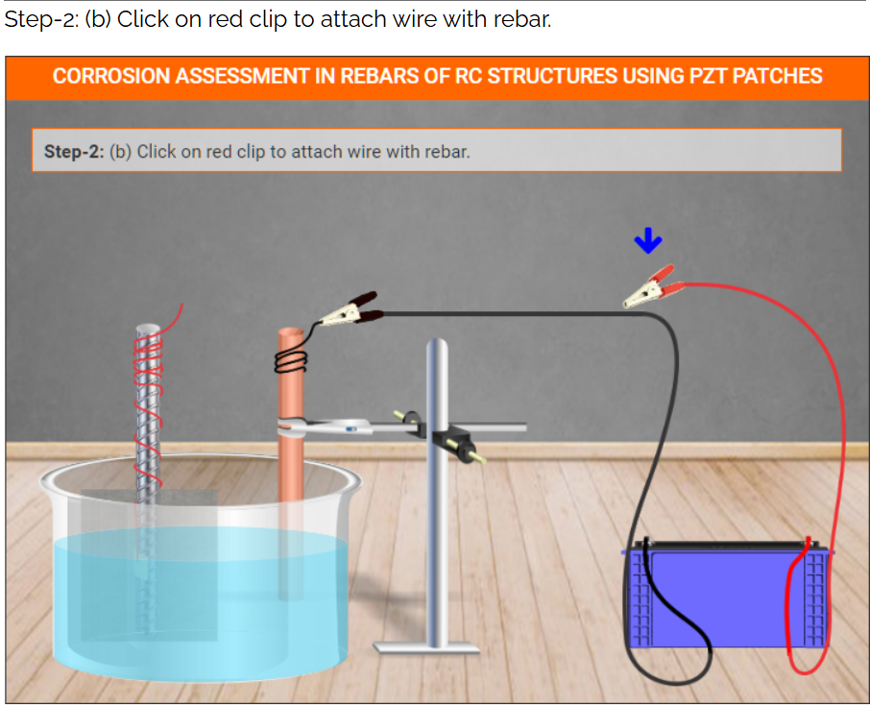
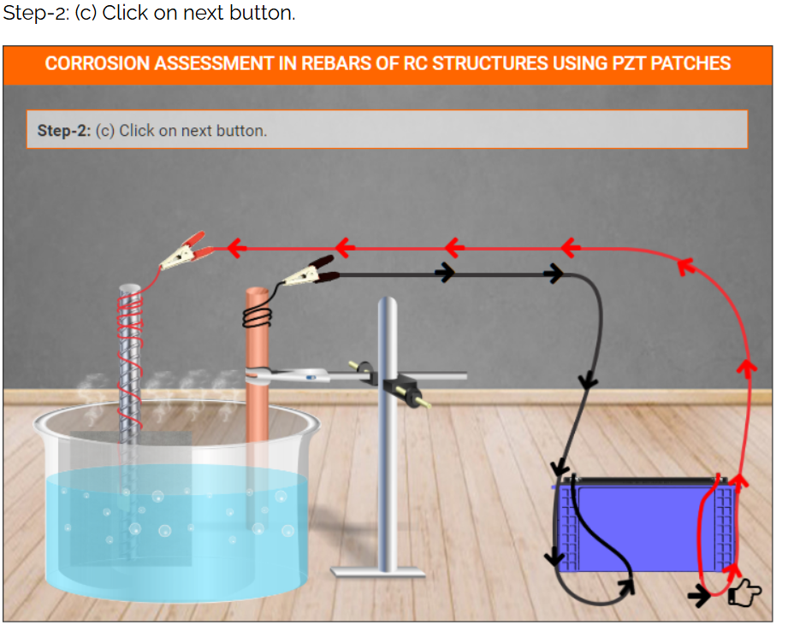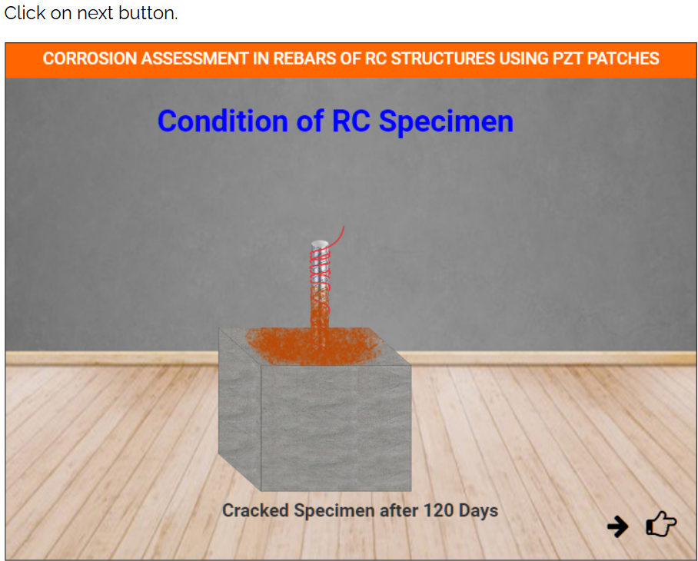
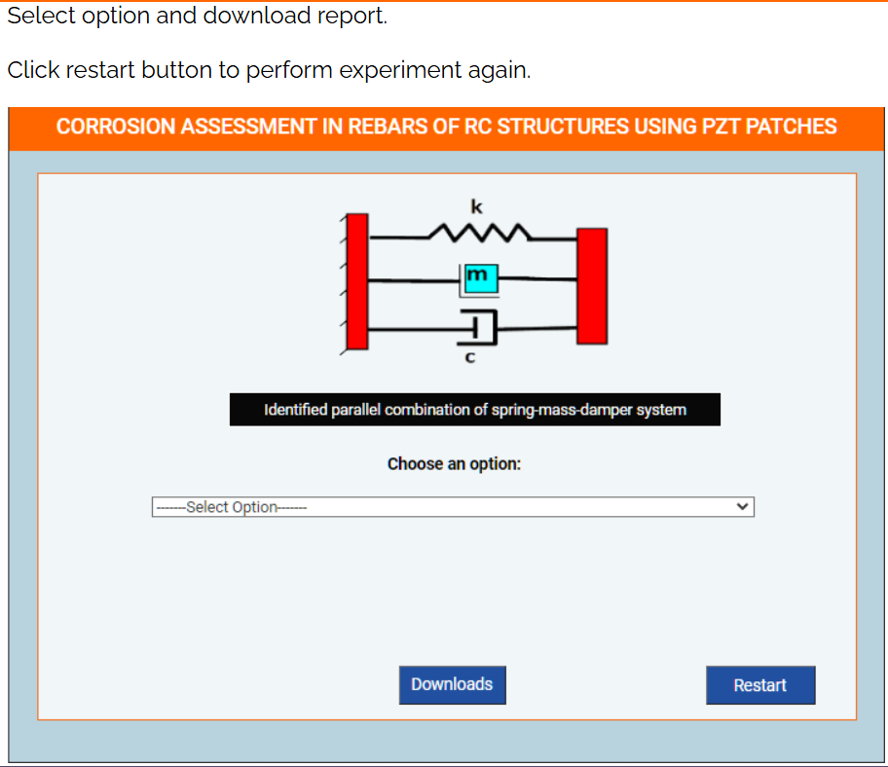

OBSERVATIONS
EXPERIMENT 5A: BARE REBAR
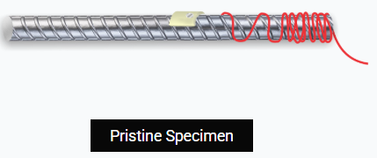

BASELINE SIGNATURE:
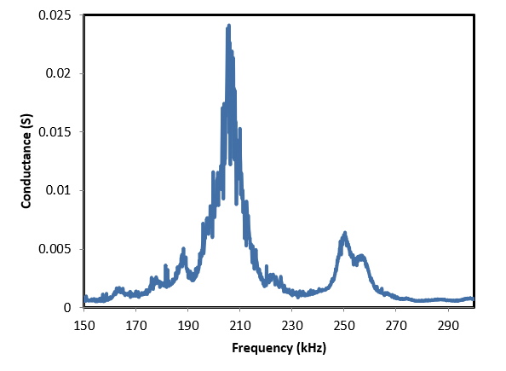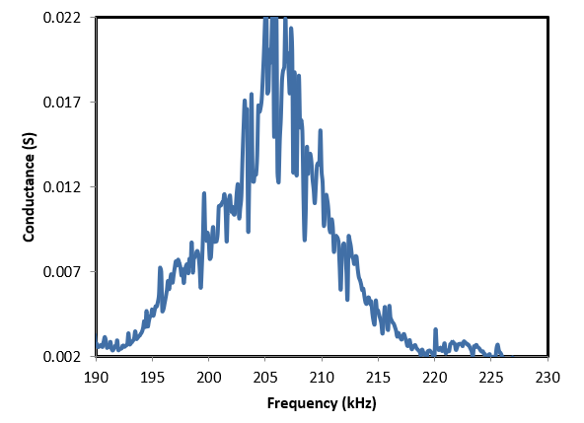
SIGNATURE AFTER HOURS OF ACCELERATED CORROSION EXPOSURE:
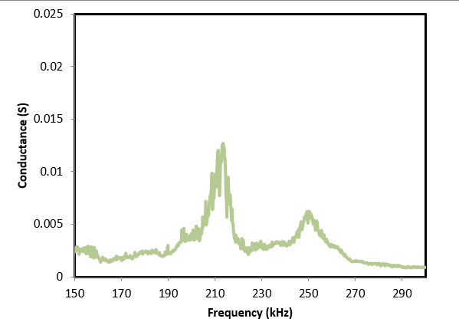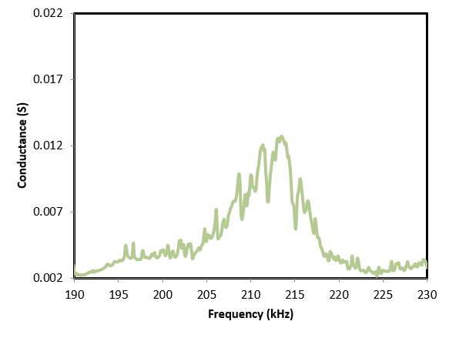

COMPARE BASELINE AND CORRODED SIGNATURE
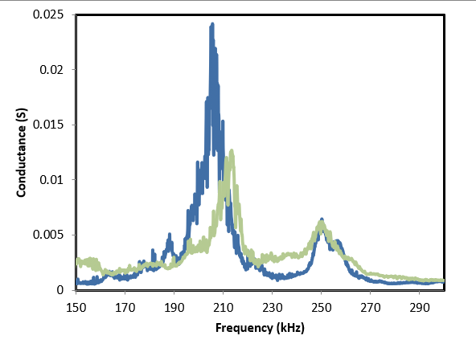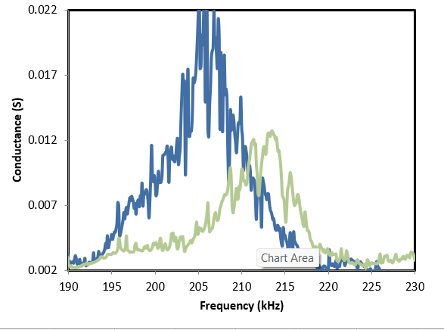
EXTRACTION OF K AND M VALUES
- (b)
Variation of extracted system parameters (a) Equivalent stiffness of specimen 1and 2 (b) Equivalent mass of specimen 1 and 2
CALCULATION OF CORROSION RATE
The corrosion rate (mm/year) can be calculated as
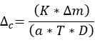
Where K is a constant equal to 8.76x10⁴, $∆m$ is the mass loss in grams, a is the area in cm², T is the time of corrosion exposure in hours and D is the density of steel i.e.,7.8g/cm³.

OBSERVATIONS
EXPERIMENT 5B: EMBEDDED REBAR
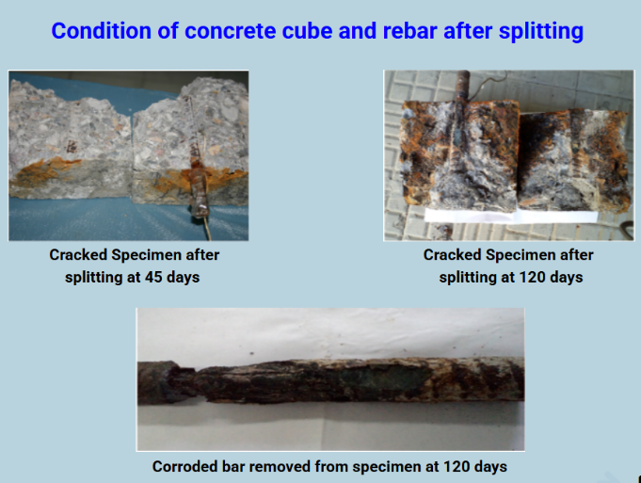

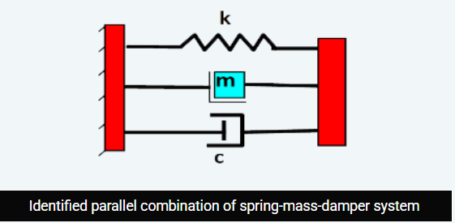

BASELINE SIGNATURE:
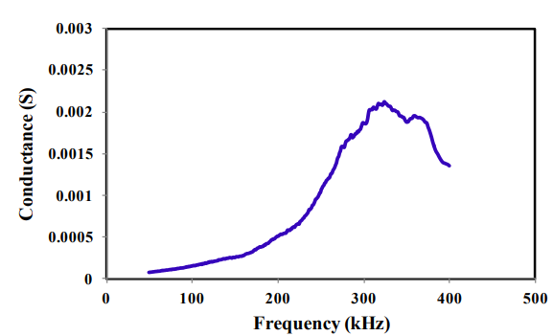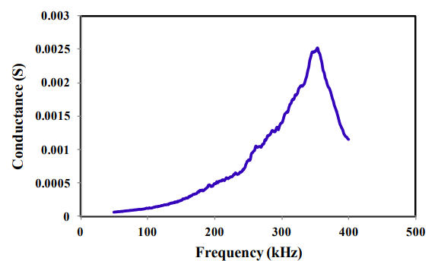
Variation of conductance signatures of specimen 1 during accelerated corrosion process
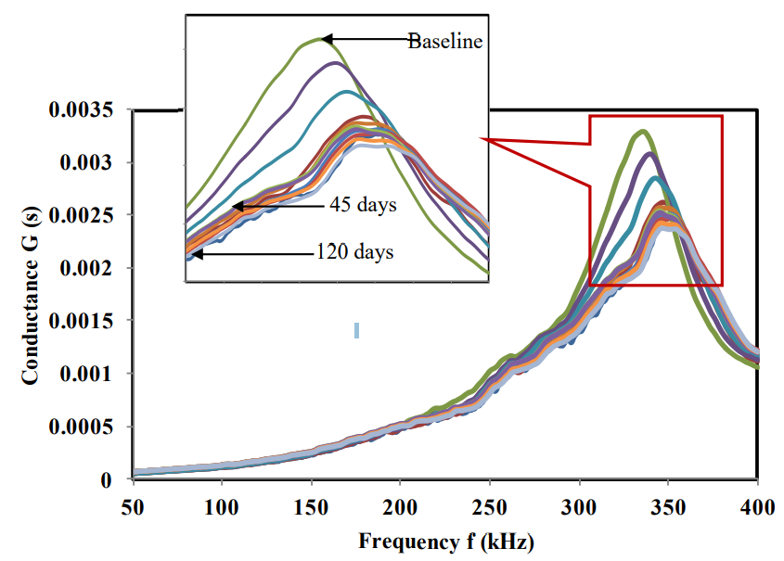

Variation of conduction signatures of specimen 2 during accelerated corrosion process
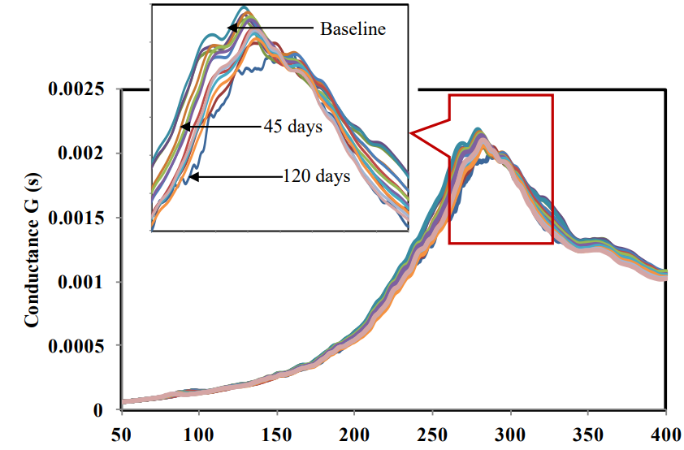

Variation of PZT identified stiffness with corrosion progress
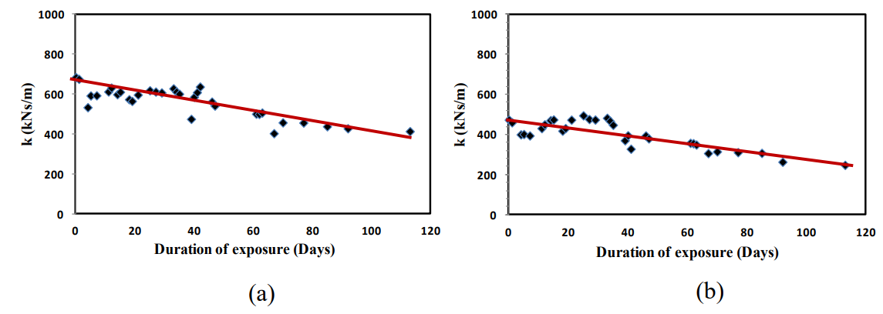
Variation of PZT identified mass with corrosion progress
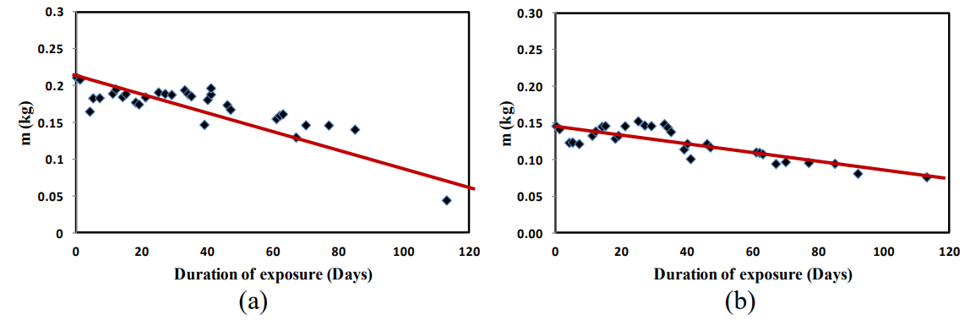

Calculation of Corrosion Rate
The corrosion rate (mm/year) can be calculated as
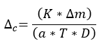
where K is a constant equal to 8.76x10⁴, $∆m$ is the mass loss in grams, a is the area in cm², T is the time of corrosion exposure in hours and D is the density of steel i.e.,7.8g/cm³.

CONCLUSION
Thus, we have assessed corrosion of rebar in RC structures with PZT patches.

